rosiwGEOMETRY Pre-SAT Topics per week

- Basic Review and Notations (1st Saturday)
- Angles and Lines (2nd Saturday)
- Triangles (3rd Saturday)
- Polygons (4th Saturday)
- Circles (5th Saturday
- If there is a 6th Saturday will do a PSAT practice

In the SAT students will be asked to asnwer questions where this knowledge is expected.

A Review of the Basics
Please make sure this terms are learned and understood (based on the SAT preparation Guide)
Points
A point is a way to describe a specific location in space. Below, the point B is pictured
A point has no length or width. Though in the picture, point B is a black dot, in real life points take up no space. Points are useful for identifying specific locations but are not objects in themselves. They only appear as objects when drawn on a page.
Lines
A line is an infinite set of points assembled in a straight formation. A line has no thickness but is infinitely long in both directions. To form a line, take any two points, A and B, and draw a straight line through them. The resulting line is a called line AB.
A line can be drawn through any two points.
Line Segments
A line segment is the portion of a line that lies between two points on that line—in this example, the portion between points A and B make up a line segment. Whereas a line has infinite length, a line segment has a finite length. A line segment is named by the two points it lies between
A line segment can be drawn between any two points.

Example showing several line segments and their labels
We will label segments by recording the endpoints. For example:
In this diagram we see several line segments:
- Segment AP is the line segment connecting A and P. Note that we can also call this segment PA.
- Segment AB (or BA if you like) runs vertically.
- Segment BP is the third segment shown.
AM, MB and MP are also segments. There is also a line in this picture. It is labeled r.
Rays
Imagine a line and a line segment mating. The result is a ray, a cross between a line and a line segment. It extends infinitely in one direction but not the other.
A ray is named by its endpoint and another point that it passes through.

A Note on Notation
The new SAT now uses standard geometric notation to indicate lines, line segments, rays, length, and congruence. It’s possible that if the students don’t know the notation, they won’t know what the question is asking them to do. So here’s a list of the correct notation. Ask them to memorize them.
Finally, they need to know the term congruent, which means “exactly the same” or “equal.” The new SAT may also test to see if they know the symbol that indicates congruence. To say that angle A is congruent to angle B, you’d write: .

Angles and Lines
An angle is a geometric figure consisting of two lines, rays, or line segments that share a common endpoint called a vertex:
In the angle above, the vertex is point A. The angle can be called either angle CAB or angle BAC. The only rule for naming an angle is that the vertex must be the middle “initial” of the angle. The SAT may also refer to angles using symbols: .
Degrees
Angles are measured in degrees. Geometric degrees are sometimes denoted by this little guy: º. There are 360º in a complete rotation around a point (that’s why a circle has 360º).
When two lines meet, they produce angles. And when two lines meet, they form four angles!
Together, the angles encompass one full revolution around the point of intersection of the two lines. So, the four angles produced by two intersection lines total 360º: angle a + b + c + d = 360º.
If you know the value of three of the four angles formed by intersecting lines, you can always find the value of the fourth.
Types of Angles
The different types of angles are named and categorized according to their number of degrees.
Zero Angles
A zero angle has 0º. To visualize a zero angle, first picture two lines that form some angle greater than 0º. Then imagine one of the lines rotating toward the other until they both fall on the same line. The angle they create has shrunk from its original measure to 0º, forming a zero angle:
Right Angles
For some reason, an angle with a measure of 90º is called a right angle. For some other reason, right angles are symbolized with a square drawn in the corner of the angle. Whenever you see that reliable little square, you know you’re dealing with a right angle.
Right angles are extremely important on the SAT. They appear in math questions all the time. Knowing their special properties will help you solve right angle questions. We give you a detailed look at those properties a little later in this chapter. For now, just remember: Always be on the lookout for right angles on the SAT.
Straight Angles
An angle with a measure of 180º is called a straight angle. It looks just like a line. Don’t confuse straight angles with zero angles, which look like a single ray.
Acute and Obtuse Angles
An angle can also be classified according to whether its measure is greater or less than 90º. If an angle measures less than 90º, it’s called an acute angle. If it measures more than 90º, it’s called an obtuse angle. Right angles are neither acute nor obtuse. They’re just right. In the picture below, is acute, while is obtuse.

Complementary and Supplementary Angles
Special names are given to pairs of angles whose sums equal either 90º or 180º. Angles whose sum is 90º are called complementary angles, while angles whose sum is 180º are called supplementary angles.
In the picture above, and are complementary, since together they make up a right angle. Angles and are supplementary, since they make up a straight line.
On the SAT, you’ll have to use the rules of complementary and supplementary angles to figure out the degree measure of an angle.
In the diagram below, AC is a line. What is x in degrees?

The picture tells you that is 113º, but how many degrees is Well, since you know that AC is a line, must be a straight angle (meaning it equals 180º). So and are supplementary angles that add up to 180º. To find out the value of you can simply take 180º and subtract 113º. = 67º.
Vertical Angles
When two lines (or line segments) intersect, the angles that lie opposite each other, called vertical angles, are always equal.
Angles and are vertical angles and are therefore equal. Angles and are also vertical (and equal) angles. We promise that the SAT will ask you at least one question involving vertical angles. Promise.

Parallel and Perpendicular Lines
Pairs of lines that never intersect are parallel. Parallel lines appear to line up right next to each other because they never meet in space. However, on the SAT, you can’t assume two lines are parallel just because they look parallel. The SAT will tell you if two lines are parallel.
Lines (or segments) are perpendicular if their intersection forms a right angle. And if one of the angles formed by the intersection of two lines or segments is a right angle, then all four angles created will also be right angles. By the way, this also shows that the degree measurement of four angles formed by two intersecting lines will add up to 360º, since 90º + 90º + 90º + 90º = 360º.
As with parallel lines, don’t assume that lines on a test are perpendicular unless the problem tells you they are. For example in the SAT they will tell you either in words (“lines a and b are perpendicular”) or by using the little box to show that the angles are 90º.
Parallel Lines Cut by a Transversal (very important for SAT)
A transversal is a line that cuts through two parallel lines. A transversal creates eight angles when it intersects with two parallel lines. The eight angles created by these two intersections have special relationships to each other.
- Angles 1, 4, 5, and 8 are equal to each other because they’re vertical angles.
- Angles 2, 3, 6, and 7 are equal to each other because they’re vertical angles.
- The sum of any two adjacent angles, such as 1 and 2 or 7 and 8, equals 180º, because these are supplementary angles.
By using these three rules, you can figure out the degrees of angles that may seem unrelated. For example, since angles 1 and 2 sum to 180º, and since angles 2 and 7 are equal, the sum of angles 1 and 7 also equals 180º. The SAT will almost definitely include a question that asks you to solve for an angle whose measurement at first glance seems impossible to determine.

Triangles

Triangle Angle Sum Theorem
The sum of the measures of the interior angles of a triangle is 180.
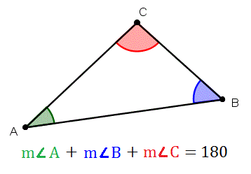

Exterior Angle Theorem
The measure of an exterior angle of a triangle is equal to the sum of the measures of the two remote interior angles.
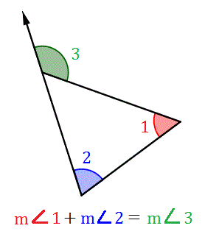
Adding the measures of the two remote interior angles of a triangle gives the measure of the exterior angle.

Bisectors of Triangles
As you well know by now, being able to deduce key information from a limited set of facts is the basis of geometry. An important type of segment, ray, or line that can help us prove congruence is called an angle bisector. Understanding what angle bisectors are and how they affect triangle relationships is crucial as we continue our study of geometry. Let's investigate different types of bisectors and the theorems that accompany them.

Perpendicular Bisector
A perpendicular bisector is a special kind of segment, ray, or line that
(1) intersects a given segment at a 90° angle, and
(2) passes through the given segment's midpoint.
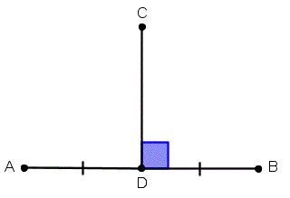
Segment CD is the perpendicular bisector to segment AB.
We derive two important theorems from the characteristics of perpendicular bisectors. We can use these theorems in our two-column geometric proofs, or we can just use them to help us in geometric computations.

Perpendicular Bisector Theorem
If a point lies on the perpendicular bisector of a segment, then it is equidistant from the endpoints of the segment.Converse also true: If a point is equidistant from the endpoints of a segment, then it lies on the perpendicular bisector of the segment.
These theorems essentially just show that there exist a locus of points (which form the perpendicular bisector) that are equidistant from the endpoints of a given segment which meet at the midpoint of the segment at a right angle. An illustration of this concept is shown below.
The perpendicular bisectors of a triangle have a very special property. Let's investigate it right now.
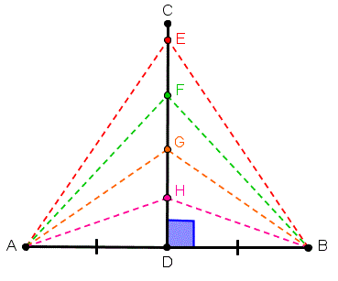
Points E, F, G, and H (along with an infinite amount of points) are equidistant from A and B. Together, they form the perpendicular bisector of segment AB.
The perpendicular bisectors of a triangle have a very special property. Let's investigate it right now.

Circumcenter Theorem
The perpendicular bisectors of the sides of a triangle intersect at a point called the circumcenter of the triangle, which is equidistant from the vertices of the triangle.
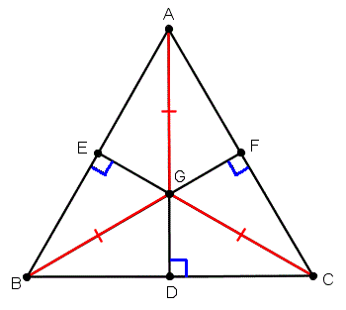
Point G is the circumcenter of ?ABC.

Angle Bisectors
Now, we will study a geometric concept that will help us prove congruence between two angles. Any segment, ray, or line that divides an angle into two congruent angles is called an angle bisector.
We will use the following angle bisector theorems to derive important information from relatively simple geometric figures.

Angle Bisector Theorem
If a point lies on the bisector of an angle, then it is equidistant from the sides of the angle.
Converse also true: If a point in the interior of an angle is equidistant from the sides of the angle, then it lies on the bisector of the angle.
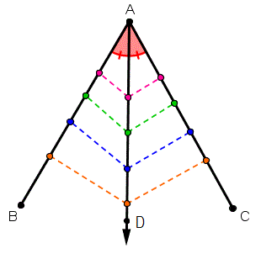
The points along ray AD are equidistant from either side of the angle. Together, they form a line that is the angle bisector.
Similar to the perpendicular bisectors of a triangle, there is a common point at which the angle bisectors of a triangle meet. Let's look at the corresponding theorem.

Incenter Theorem
The angle bisectors of a triangle intersect at a point called the incenter of the triangle, which is equidistant from the sides of the triangle.
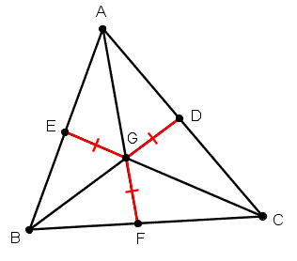
Point G is the incenter of ?ABC.

Exercise 1
BC is the perpendicular bisector of AD. Find the value of x.
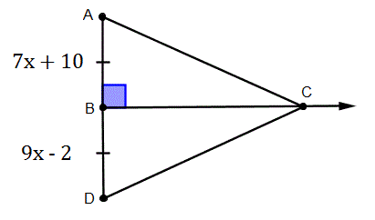
Solution:

Exercise 2
N is the circumcenter of ?RAK. Find the values of x and y.
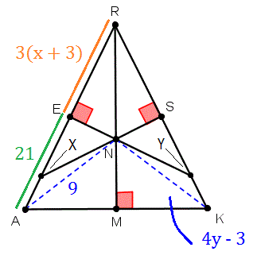

POLYGONS
- Polygon Types
- Polygon Perimeter
- Polygon Area
- Polygon exterior and interior angles
- Apothem
- Calculating missing angle
- Finding the unknown side

CIRCLES
- Arc measure
- Arc length
- Introduction to radians
- Arc length in radians
- Inscribed angles
- Inscribed shapes
- Expanded equation of the circle.

